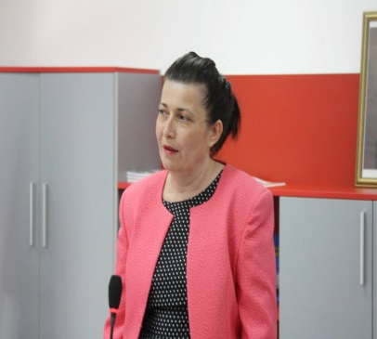
Galina Momcheva-Gardeva
Associate Professor
Varna Free University,
Varna, Bulgaria

Biography
Dr. Galina Momcheva is an Associate Professor in Computer Science at Varna Free University “Chernorizets Hrabar”, Bulgaria. She was the Head of Department of Computer Science (2013-2015) and now she is the Head of Department of Computer Science and Economics (since 2015) after some structural reforms.
After strong background (more than 15 years) in Programming and Data Structures and Algorithms including preparation of competitors in informatics in Bulgaria she is still a supervisor of research projects of young scientists (Bioinformatics, Computer Vision). Now she has strong research interests in data mining, semantic data, visualizations and UI/UX.
She develops at VFU and leads master degree programs in ‘Data Science’ (2016), ‘Software Engineering and Management’ (2016) and ‘Computer Games and Animation’ (2014).
Dr. Momcheva is a member of ACM (since 2006), member of the Union of Bulgarian Mathematicians and its executive board in Varna region (1995-2016) and also she is the Charman of ICT Cluster-Varna (since 2016).
She is an Oracle Academy lecturer and an initiator of a lot of activities for computer science for fun and visual programming for students’ classes in the country. She participates in national educational standards developing teams of experts.

Research Interest
Data Science, Data Visualizations, Semantic Data, Social Network Analysis, UI/UX,
Entrepreneurial Ecosystems’ Development, Computer Science Education

